NAME: AGBANU RAPHAEL EDEM
ID: 22428645

Network Analysis of Research Group Members
1. Introduction
This report presents a simple social network analysis of members of a research group. The objective is to model and visualize the relationships among the members, compute key network metrics, and interpret the structure of interactions within the group.

2. The analysis uses six individuals:
Edem, Priscilla, Philip, Gilbert, Mark, and Lydia
A graph (network) was constructed where each member represents a node, and an edge indicates a direct working relationship.

3. Methodology
The network was created using Python (NetworkX) with a manually defined relationship structure.
The steps performed include:
1. Creating nodes for each member.
2. Adding edges representing collaboration or interaction.
3. Computing the following metrics:
- Number of nodes
- Number of edges
- Degree of each node
- Degree distribution
- Identification of isolated nodes
4. Visualizing the network using a spring-layout graph.
5. The resulting visualization and metrics reflect the current collaborative structure within the group.

3. Results
3.1 Number of Nodes and Edges
Nodes: 6
Edges: 6
This shows that the network is connected, with most individuals linked through Edem or Priscilla.
3.2 Screenshot of visualization

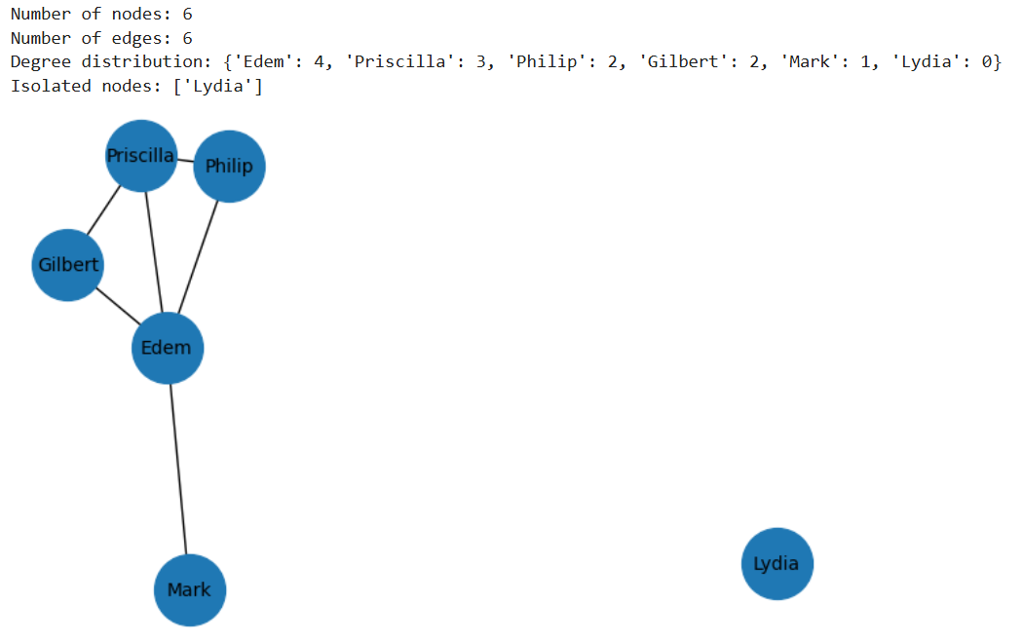

3.3 Degree Distribution
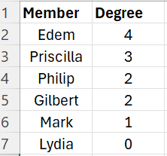

3.4 Interpretation:
Edem is the most central member (degree 4), acting as the main connector in the group.
Priscilla is also an influential node with degree 3.
Philip and Gilbert have moderate connections (degree 2), linking them to the core of the network.
Mark has minimal interaction (degree 1), connected only through Edem.
Lydia is an isolated node, meaning she has no direct relationship with any group member in the data provided.
4.Conclusion.
This analysis demonstrates how social network modelling can reveal interaction patterns within a research group.

